Please read the class descriptions carefully. Some of the classes are offered only once and some are offered twice. Please have your shuttles for each class prepared in advance, as required, to save class time. Classes will be filled on a first come basis. All classes will be 2 hours.
Skill levels are defined as:
Adv. Begin: knows the basics – rings, chains, picots, joins and reading patterns
Intermediate: knows and is comfortable with the above, plus two shuttles, split rings/chains, beads
Advanced: knows and is comfortable with all of the above and ready for more.
Friday class sessions begin at 12:45 p.m. and 3:00 p.m.
Saturday class sessions begin at 9:15 a.m., 12:45 p.m. and 3:15 p.m.
If you have any questions, please contact us at shuttlebirds.workshop@yahoo.com

FRIDAY 12:45 – 2:45 p.m. Classes

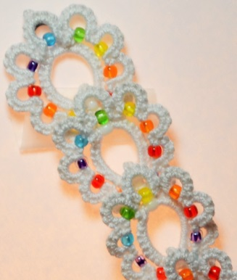
Kaleidoscope Motif Teacher: Davina Achen
Class Type: Technique Level: Intermediate
Class Limit: 15 Repeats on Saturday at 9:15 a.m.

Class will focus on the techniques needed to make the kaleidoscope motif. Single motifs can be used as earrings while chains of motifs make amazing looking bracelets and necklaces. Also included will be some new, improved techniques for hiding ends and preparing tatted objects for the addition of jewelry fasteners.
Skills Required: Basic tatting skills plus split rings, and the ability to maintain a consistently tight tatted chain and string beads.
Techniques Taught: How to connect the rings so the motif maintains is strength and stability.
Materials: For the bracelet – 2 shuttles wound full CTM with 150 size 11 seed beads threaded into the center. Single colors are best for learning.
Kit: Optional, $3.50. Pre-strung beads in a pattern.

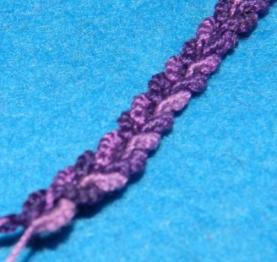
Double Split Ring Lanyard Teacher: Cheryl Birch
Class Type: Technique Level: Intermediate
Class Limit: 15 Repeats on Saturday at 12:45 p.m.

Make a chain of interlocked split rings to use as a lanyard or eye glass strap. We will also discuss how the use of color plays a role in changing the look of your finished project. Bonus project – convert a pen into a hook for your tatting bag.
Skills Required: Split Rings, using 4 shuttles.
Techniques Taught: Interlocking split rings.
Materials: 2 pairs of shuttles wound CTM, size 20 thread in color(s) of your choice, full size crochet hook and your basic tatting kit.
Kit: $1.50, contains pen and 2 lanyard clips.

What Do I Do Now???? Teacher: Venessa Godfrey
Class Type: Project Level: Adv. Begin
Class Limit: 4-6 Repeats on Saturday at 3:15 p.m.

Have you tried a pattern and gotten stuck? Do you have an old project, one you are unable to finish? Are you having trouble getting started? Bring the pattern and the tatted piece worked to that “iffy” part and let’s figure it out together.
Skills Required: rings, chains, joins, basic pattern reading.
Techniques Taught: dependent on the student.
Materials: project, pattern and threads needed to work on the project the student is getting assistance with, plus basic tatting kit.
Note: Venessa will contact you after your class confirmation. You will need to email her the pattern you wish help with prior to the workshop.
Kit: None
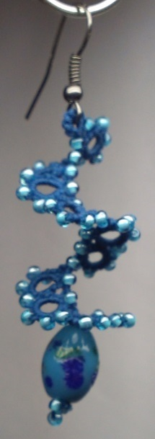
DNA Spiral Earrings Teacher: Diana Howe
Class Type: Technique Level: Adv. Begin.
Class Limit: 15 Repeats on Saturday at 3:15 p.m.

Beads are fun. They add color and sparkle to your tatting and can also enhance the design. This earring pattern uses beads on both threads to outline the spiral.
Skills Required: basic tatting skills – rings, chains, picots and joins.
Techniques Taught: adding beads.
Materials: 2 Shuttles, size 20 or 40 thread, size 11 seed beads as follows: wind CTM with 4 yards and 47 beads on 1st shuttle and 1 yard with 15 beads on 2nd shuttle per earring, plus 1 or more focal beads for each earring, basic tatting kit.
Kit: None

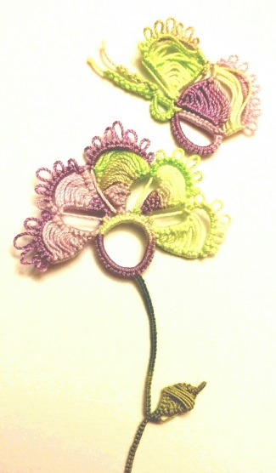
Garden Motif Teacher: Natalie Rogers
Class Type: Technique Level: Intermediate
Class Limit: 15 Repeats on Saturday at 9:15 a.m.

Language should not be a barrier for learning new techniques to create beautiful lace. “Mekik Oyasi” translates from Turkish into “tatted lace”. Natalie does not know the specific name for this technique but many refer to it as “Turkish tatting.” She will walk you through how to create it with butterfly and flower motifs for practice this. A collection of photos will be available to show you various ways the technique has been used in tatting patterns from edgings to doilies.
Skills Required: rings, chains, picots, joins, pattern reading and split rings.
Techniques Taught: Turkish tatting.
Materials: for 1 color: 2 shuttles wound CTM with thread size and color of choice. For 2 colors: 2 shuttles wound with different colors of thread size of your choice.
Kit: None

Self-Improvement Teacher: Georgia Seitz
Class Type: Technique Level: Adv. Begin.
Class Limit: 15
This course presents an overview of the many tatting techniques that a new tatter will be encountering. It should serve to demystify many terms and to inspire the tatter to attempt new techniques as they encounter them. The class provides an overlook of many ring types, self-closing mock rings, split rings, split chains, many join types, encapsulation, pearl tatting, and basic needle tatting.
Homework: Details will be provided with your confirmation.
Skills Required: Basic tatting skills: ring, chain, picot, join.
Materials: Your completed homework plus 3 shuttles, 1 tatting needle and 2 colors of thread – size 20 is fine but match the thread size to the needle also.
Kit: None

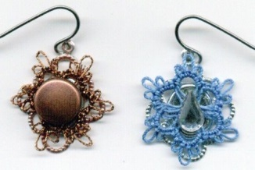
Filigree Tatted Earrings Teacher: Lauren Snyder
Class Type: Project Level: Adv. Begin
Class Limit: 15 Repeats on Saturday at 3:15 p.m.

Tat a tiny snowflake or motif; secure it to a filigree finding and the cover the center with a flat bead.
Skills Required: Basic tatting skills: ring, chain, picot, join.
Techniques Taught: quick overview of coloring metals, using glue dots.
Materials: 1 shuttle wound with 5 yards of thread, size 30 or smaller or DMC Diamant metallic, picot gauge and basic tatting kit.
Kit: Required, $1.00, includes 1 pair each of stainless steel hooks, filigree findings, and beads, glue dots

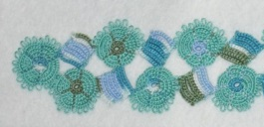
Block & Wheel Bookmark Teacher: Karey Solomon
Class Type: Technique Level: Advanced
Class Limit: 15 Repeats on Saturday at 12:45 p.m.

Continuous Catherine wheels are paired with block tatting to create an interesting bookmark that showcases variegated threads.
Skills Required: Basic tatting skills: ring, chain, picot and join, plus a smile and determination to get where you need to be.
Techniques Taught: Continuous Catherine wheels, neat block tatting with even edges, thread management for color, alligator join and front-side/back side tatting.
Materials: 2 shuttles, 2 colors of thread in size 10 (recommended) or 20, plus basic tatting kit.
Kit: None

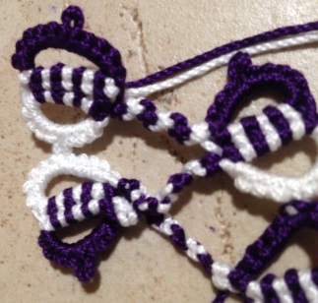
Fused Rings Teacher: Jessica Spaulding
Class Type: Technique Level: Advanced
Class Limit: 15 Repeats on Saturday at 9:15 a.m.

Size 3 thread has opened up the possibilities for interesting stitches. Make 2 rings at once and fuse them together. This is an idea taken from page 28 of Anne Dyer’s book To Boldly Go Where No Shuttle Has Gone Before, and described as “This method of joining gives a more solid effect than using picots, and gives contrasting density to the work.” Class will learn and practice this exciting new ring construction and discuss ways to incorporate it into patterns.
Skills Required: Be comfortable manipulating multiple threads at the same time.
Techniques Taught: Making two rings simultaneously.
Materials: 2 shuttles wound with contrasting colors of the same size thread – either 3 or 10 only.
Kit: None

FRIDAY 3:00 – 5:00 p.m. Classes

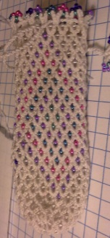
Mignonette Shuttle Bag Teacher: Davina Achen
Class Type: Technique Level: Intermediate
Class Limit: 15

Tat a cute beaded shuttle bag. Students will learn how to tat a flat base and then how to tat up the sides of the bag using the mignonette stitch. We will also cover how to complete the top of the bag. While you are working, we will discuss different ways mignonette can be used, alternative beading designs and technique and working with larger shuttles.
Skills Required: Ability to use 2 shuttles and the larger Tatsy shuttles, plus split rings.
Techniques Taught: Mignonette stitch and sizing.
Materials: These are thread and bead heavy designs. Registered students will be contacted in early March to discuss how to set up their own kit or for purchasing options.
Kit: Extra kits will be available in the vending area.

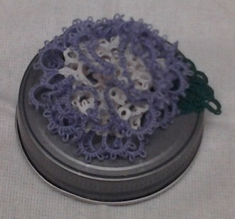
Jazzy Jars Teacher: Cheryl Birch
Class Type: Project Level: Intermediate
Class Limit: 15

Make a 3-D carnation to decorate the top of a Mason jar. While working on the flowers, we will talk about color and how its use can change the look of your finished piece. We will also discuss ideas for filling the jars with edibles, potpourri, etc., to give as a gift or just for fun. Bonus project – convert a pen into a hook for your tatting bag.
Skills Required: Basic tatting skills: rings, chains, picots and joins, plus split rings and chains.
Materials: 2 shuttles wound full (Moonlit shuttle is recommended for shuttle making the rings) CTM with size 20 in white or natural, or white/natural and 1 color; full size crochet hook and basic tatting kit. Reference book (not required): The Complete Book of Tatting by Rebecca Jones.
Kit: Required, $3.00 includes pen and jar lid.

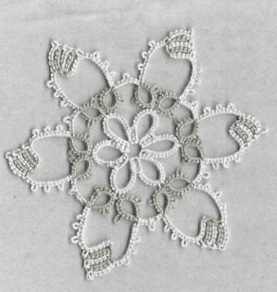
Block Tatting Teacher: Mary McCarthy
Class Type: Technique Level: Intermediate
Class Limit: 15

Explore two methods of block tatting, how to make the blocks and the use of color.
Skills Required: Basic tatting skills plus reverse (un-flipped) or knot stitch (second half of split ring).
Techniques Taught: Block tatting.
Materials: 2 shuttles wound with 2 colors of size 10 thread plus basic tatting kit.
Kit: None

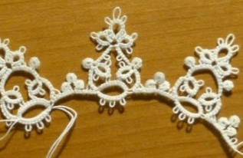
Heirloom Lace Teacher: Kathleen Minniti
Class Type: Technique Level: Adv. Begin.
Class Limit: 15

Achieve polished results and work with fine threads. Class will explore the details that take our lace from handicraft to heirloom. The two shuttle pattern presents opportunities to experiment with counting and not counting joins as part of a double stitch; see the difference working the Josephine picot with a right or left handed stitch can make; practice making snug connections between chains at the base of rings; and learn how to make a small, tight lock join that won’t stretch. We will also share our tips and experiences working with fine threads to help those who haven’t tried it yet. The sample is worked in DMC Cordonnet, size 100.
Skills Required: Basic tatting skills: rings, chains, using 2 shuttles.
Techniques Taught: Front-side/back-side, Josephine picots, controlling twist, magic threads for hiding ends.
Materials: 2 pairs of shuttles – one pair wound CTM with size 20 or larger and one pair wound CTM with size 70 or smaller.
Kit: None

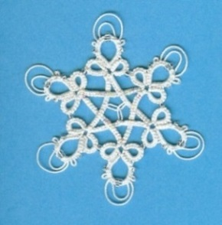
Snowflake 2014 Teacher: Dale Pomeroy
Class Type: Project Level: Advanced
Class Limit: 15 Repeats on Saturday at 12:45 p.m.

Create this beaded snowflake using 4 shuttles plus blending filament simultaneously. The complete pattern takes approximately 4 hours to complete.
Skills Required: Rings, chain over/under joins, reverse stitches, beaded picot joins, beads on both threads, Celtic knotted picot, padded tatting/tweed tatting, extended picots, using a picot gauges, working with 2 pairs of shuttles plus a filament simultaneously.
Techniques Taught: Any aforementioned skills as needed.
Materials: 4 shuttles, size 20 thread, 1 blending filament, 6 size 11 seed beads, 30 petite beads, size 16 crochet hook and your basic tatting kit. Wind 2 shuttles full, placing 15 petite beads on each. Wind the other two shuttles with 1½ yards of thread on each. NO continuous thread winding.
Kit: None

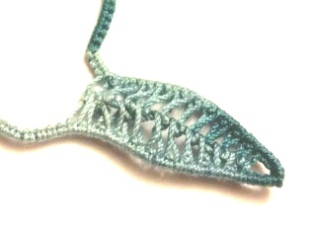
Falling Leaves Teacher: Natalie Rogers
Class Type: Technique Level: Intermediate
Class Limit: 15 Repeats on Saturday at 12:45 p.m.

Do your leaves lack center veins? Do you want to play around with picots joined to other picots? Would you like to learn several different motifs to practice inverted tatting? Come add inverted tatting to your bag of tricks!
Skills Required: Chains picots and joins.
Techniques Taught: Inverted tatting, ball thread join.
Materials: 2 shuttles wound CTM with size 20 thread, picot gauges and your basic tatting kit.
Kit: None

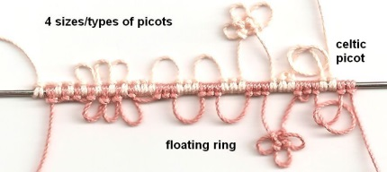
Variations on Needle Tatted Chains Teacher: Georgia Seitz
Class Type: Technique Level: Adv. Begin.
Class Limit: 15

The method of needle tatting allows us to use fat, fluffy, metallic and textured fibers on the needle which would neither wind well nor pull through well in shuttle tatting. It is also economic in that a less expensive thread may be used as a separate carrying cord (as it does not show) and the more expensive threads used on the outside. The techniques of both the split ring and split chain are much less complicated on the needle, too. Floating rings are somewhat more difficult. Working with beads is much easier. So there are both advantages and disadvantages. In short, it is well for the tatter to master both styles of tatting. Whatever is wrapped on the needle may be formed into a ring (as in self-closing mock ring) or a chain at the moment of closing. Thus, the importance and the versatility of the pearl tatted chain comes into play. Not only may multiple threads be brought into action, but both sides of the chain may be decorated.
Homework: Details will be provided with your confirmation.
Skills Required: Basic needle tatting will be taught in class and is intended to encourage shuttle tatters to try needle tatting. Those with needle tatting experience will be encouraged to try exotic techniques.
Techniques Taught: Needle tatting wrapping with one and with two hands, rings, chains, pearl tatted/Maltese chains, beaded chains, joins, picots, joining, decorative and Celtic, throwing rings off a pearl tatted chain, bicolor and multicolor chains, the use of a picot gauge and if time permits, the needle tatted bicolor ala Helen Free.
Materials: Your completed homework plus 2 shuttles, 1 tatting needle, and 3 colors of thread. Size 20 is fine but match the thread size to the tatting needle. Beads are welcome and some will be provided.
Kit: None

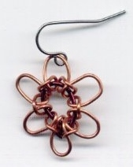
Tatting with Pliers Teacher: Lauren Snyder
Class Type: Project Level: No tatting skills required
Class Limit: 15 Repeats on Saturday at 12:45 p.m.

An understanding of the tatting knot is useful but you will NOT need to know how to tat for this class. Using 18 (or 20) and 22 gauge wires and a pair of round nose pliers, make a pair of “tatted” rings suitable for use as links in earrings, a bracelet or a necklace. We will make earrings in class.
Skills Required: A willingness to try something different.
Techniques Taught: How to hold and bend wire with pliers.
Materials: A small spool of 18 or 20 gauge wire (uncolored is best), 12 inches of 22 gauge wire, a pair of fine needle nose pliers and a pair of flush cut wire cutters.
Kit: No cost, includes a pair of earwires.

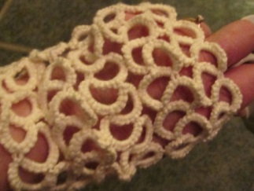
Elegant Tea Mitts Teacher: Karey Solomon
Class Type: Project Level: Intermediate
Class Limit: 15

Victorian ladies wore these to shield the delicate back-of-the-hands skin from the sun. Using larger (size 3) thread or tat-able cotton fingering-weight yarn, we can create a wearable, totally-tatted garment that is comfortable and customized to the wearer. You probably won’t finish both mitts in class, but you will know how to.
Skills Required: Basic tatting skills: ring, chain, picot and join. Knowledge of split chain is helpful but not essential.
Techniques Taught: How to handle larger shuttles and thicker thread, Marie Smith’s method of the split chain, and creating tatting that fits the wearer.
Materials: 1 ball of size 3 thread, 1 large shuttle (Starlit or Tatsy recommended), needle for finishing and basic tatting kit.
Kit: Optional. A Starlit shuttle with size 3 Lizbeth thread may be pre-ordered from Karey at threads@empacc.net

SATURDAY 9:15 – 11:15 a.m. Classes

Kaleidoscope Motif Teacher: Davina Achen
Class Type: Technique Level: Intermediate
Class Limit: 15
See Friday at 12:45 p.m. for class description.
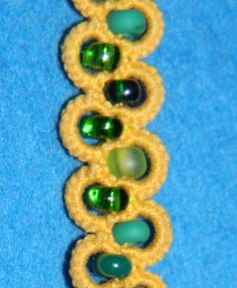
Beaded Lanyard Teacher: Cheryl Birch
Class Type: Technique Level: Intermediate
Class Limit: 15

If you have admired the lanyards worn at previous workshops and want one, then come make your own. This class is Gary Houtz’ version of Patti Duff’s pattern. And as the Shuttle Brothers say “It’s the same but different.” Patti’s original design is a single shuttle, one thread, rings only pattern while Gary uses self-closing mock rings to achieve the same look. With Gary’s version, you may use 2 shuttles with 1 or 2 colors of thread, or 1 shuttle and ball with the shoelace trick between each ring. Bonus project – convert a pen into a hook for your tatting bag.
Skills Required: Basic tatting skills – ring, chain, picot, join.
Techniques Taught: Self-closing mock ring (SCMR) with bead at the base, shoelace trick (SLT) if needed.
Materials: 1 or 2 shuttles, 1 or 2 colors of thread in complimentary or contrasting colors, 259 size 6 seed beads in a color or colors to compliment or contrast your thread, full size crochet hook, coil-less safety pins and basic tatting kit.
Kit: $1.50, includes pen and lanyard clips

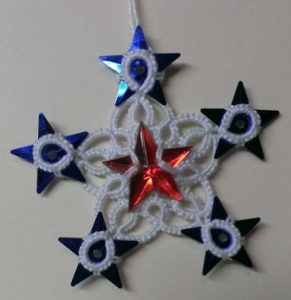
Sparkly Star Motif Teacher: Diana Howe
Class Type: Technique Level: Adv. Begin
Class Limit: 15

Add some sparkle to your tatting. Encapsulate sequins between stacked rings and add a button in the center to create this star shaped motif.
Skills Required: Basic tatting skills: ring, chain, picot and join, plus using 2 shuttles.
Techniques Taught: adding buttons, stacked rings.
Materials: 2 shuttles wound CTM with size 20 thread – 2 yards on 1st shuttle and 3 yards on 2nd shuttle, needle threader of small crochet hook plus basic tatting kit.
Kit: Required, $0.25, includes one star button and 5 sequins

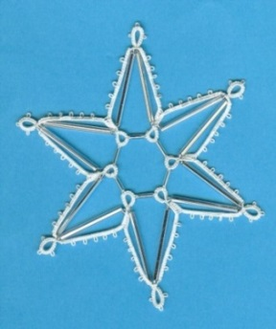
Snowflake 2013 Teacher: Dale Pomeroy
Class Type: Project Level: Intermediate
Class Limit: 15

This open-centered medallion uses two sizes of bugle beads and is worked in two rounds.
Skills Required: Rings on opposite sides of the thread, beaded picot joins, chains and shuttle/lock joins.
Techniques Taught: Any aforementioned skills needed.
Materials: Tatsy shuttle, size 20 thread, size 16 crochet hook, 24 size 11 seed beads, 12 30mm bugle beads and 6 ¼” bugle beads. Wind the shuttle with Cordonnet adding seed bead, 30mm bugle bead, seed bead x12.
Kit: None

Garden Motif Teacher: Natalie Rogers
Class Type: Technique Level: Intermediate
Class Limit: 15
See Friday at 12:45 p.m. for class description.

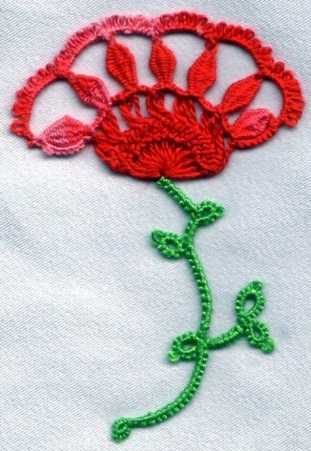
Cluny Flower Teacher: Georgia Seitz
Class Type: Technique Level: Intermediate
Class Limit: 15

This floral motif, by Dagmar Pezzuto, combines tatting, cluny tatting and hairpin lace.
Skills Required: Basic tatting skills – ring, chain, picot and join.
Techniques Taught: Hanging cluny tatting, hairpin lace and/or all tatted hairpin lace.
Materials: 2 pairs of shuttle wound CTM in one or two colors for the blossom part; another set pair of shuttles or 1 shuttle and the ball, for the stem. 1 tatting needle and thread if desired. 3 colors of thread as noted above. Size 20 thread is fine but match the thread size to the needle also.
Kit: Required, $1.00, includes a plastic cluny loom and hairpin loom.

Filigree Tatted Earrings Teacher: Lauren Snyder
Class Type: Project Level: Adv. Begin
Class Limit: 15
See Friday at 12:45 p.m. for class description.

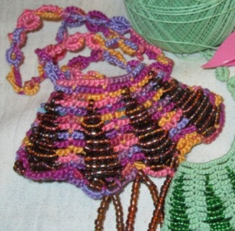
Beaded Reticule Teacher: Karey Solomon
Class Type: Technique Level: Intermediate
Class Limit: 15

I love the style of beaded knitted bags and wanted to reproduce them in tatting. After a lot of experimentation, I found a way to it using chains only and lots and lots of beads. The tatted bags hold their shape better than the knitted ones, and are fun to tat. In the class, you will get a good start on the project so finishing should be a breeze afterwards.
Homework: Pre-string the beads on your ball of thread.
Skills Required: Basic tatting skills – chain, and ability to persevere.
Techniques Taught: Using beads to shape a fabric, management of a large number of beads.
Materials: Large post shuttle – Clover, Starlit or Tatsy, size 3, 10 or 20 thread, 525 seed beads in size 6, 8 or 11, a paper clip, small crochet hook and your basic tatting kit.
Match the bead size to your thread size as follows: size 6 bead with size 3 thread, size 8 bead with size 10 thread, size 11 bead with size 20 thread. String 525 beads on your thread. (string on 55 beads first, measure the length of the beaded thread and use that as a guide rather than counting. 525 is a few more beads than actually needed.) Wind the shuttle as full as possible with 235 beads, leaving the rest on the ball.
Kit: None

Fused Rings Teacher: Jessica Spaulding
Class Type: Technique Level: Advanced
Class Limit: 15
See Friday at 12:45 p.m. for class description.

SATURDAY 12:45 – 2:45 p.m. Classe

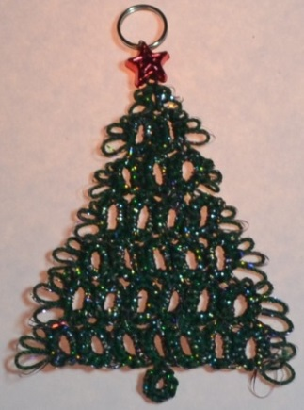
Sparkle Tatting a GoGo Teacher: Davina Achen
Class Type: Technique Level: Adv. Begin.
Class Limit: 15

Some designs just scream for a little something extra. In this class you will learn how to wind your shuttles with 1-3 pieces of filament and how to adjust your tension as you work to accommodate the extra threads. We will also cover what to do when things go wrong and how to get back on track. Bring a small motif, or one will be provided, to play with during class.
Skills Required: Basic tatting skills – ring, chain, picot, join.
Techniques Taught: How to set up, tat and finish a motif with an extra filament.
Materials: 1 empty shuttle and size 20 or larger thread.
Kit: Required, $2.00, includes filament and pattern. Extra kits will be available in the vending area.
Split Ring Lanyard Teacher: Cheryl Birch
Class Type: Technique Level: Intermediate
Class Limit: 15
See Friday at 12:45 p.m. for class description.

Split Chains Teacher: Mary McCarthy
Class Type: Technique Level: Intermediate
Class Limit: 15

Learn to make split chains for continuous tatting between rounds and fitting into small spaces where a shuttle doesn’t fit. The split chain technique is also used for covering cabone rings.
Skills Required: Basic tatting skills – ring, chain, picot, join.
Techniques Taught: split chain
Materials: Your basic tatting kit.
Kit: None

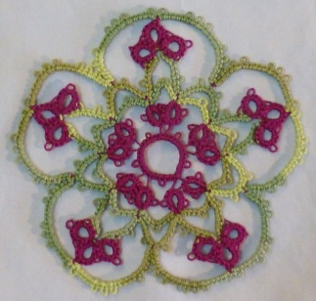
Balanced DS Coaster Teacher: Kathleen Minniti
Class Type: Technique Level: Intermediate
Class Limit: 15

By the time you finish this deceptively simple balanced double stitch coaster you will be thoroughly familiar with the technique! The pattern is worked in continuous rounds giving you practice climbing out with a false picot, a split ring and a split chain, all using the balanced double stitch. The pattern is lovely in two colors, but can also be worked in one color with two shuttles wound CTM. Worked in Lizbeth size 20, the sample is 3½” wide; the ones worked in Aunt Lydias’ size 10 measure a generous 4¾” across.
Skills Required: Basic tatting skills – ring, chain, picot, join, plus split rings.
Techniques Taught: Balanced double stitch, split chain for two color work.
Materials: 2 shuttles wound with 14 yards each in two different colors, picot gauge, crochet hook and your basic tatting kit.
Kit: Optional, $10.00, includes two large Clover shuttles pre-wound with size 10 thread and picot gauge appropriate for the pattern.

Snowflake 2014 Teacher: Dale Pomeroy
Class Type: Project Level: Advanced
Class Limit: 15
See Friday at 3:00 p.m. for class description.

Falling Leaves Teacher: Natalie Rogers
Class Type: Technique Level: Intermediate
Class Limit: 15
See Friday at 3:00 p.m. for class description.

Self-Improvement Plus Teacher: Georgia Seitz
Class Type: Technique Level: Adv. Begin.
Class Limit: 15

This course picks up where the Self-Improvement Course (see Friday at 12:45 p.m. for details) left off. In addition to the overlook of the many ring types, split chains, join types, et al, this course adds pearl tatting with a shuttle and with both hands for the needle, Cluny tatting, block tatting, and little tidbits of techniques for picots such as double, celtic over tatted and over crocheted, and interlocking rings.
Skills Required: Basic tatting skills – ring, chain, picot, join.
Techniques Taught: Self-closing mock rings, split rings, split chains, many join types, encapsulation, pearl tatting for shuttle and two hand needle, cluny, block, fancy picots and interlocking rings.
Materials: 3 shuttles, 1 tatting needle, 2 colors of thread. Size 20 is fine but match the thread size to the needle.
Kit: None

Tatting With Pliers Teacher: Lauren Snyder
Class Type: Project Level: No tatting skills required
Class Limit: 15
See Friday at 3:00 p.m. for class description.

Block & Wheel Bookmark Teacher: Karey Solomon
Class Type: Technique Level: Advanced
Class Limit: 15
See Friday at 12:45 p.m. for class description.

SATURDAY 3:15 – 5:15 p.m. Classes


MacGyver Your Tatting Box Teacher: Davina Achen
Class Type: Technique Level: All
Class Limit: 15

After 2 long days of learning and tatting, let’s take some time to sit together and go through all the fun items in my tatting box. From hackle pliers to rubber tubing, I will share all my hints and tricks. And when I am done, it will be your turn to share your best ideas with the rest of the class. A prize will be awarded for the most unique or surprising idea.
Skills Required: A sense of humor is a must.
Techniques Taught: How to look at just about anything and everything and say “I could use that to tat with, on, for, around, under, over and inside.
Materials: Bring your most unique or surprising idea.
Kit: None

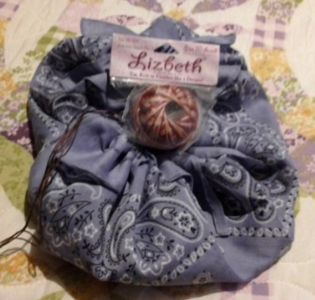
Hankie Tatting Bag Teacher: Cheryl Birch
Class Type: Project Level: All
Class Limit: 15

Who doesn’t need another tatting bag? In this make and take class, you will learn to make 2 travel bags from bandanas – one using a single bandana and the second using two. When completed, trim them with an edging of your choice. Bonus project – convert a pen into a hook for your tatting bag.
Skills Required: Basic tatting skills.
Techniques Taught:
Materials: 2 shuttles wound CTM with size 20 thread in a color to match the bandanas, 3 bandanas, a big eye needle for sewing, 1 skein of black embroidery floss, 2 recyclable cd’s, 1 full size crochet hook, 12 large coil-less safety pins and your basic tatting kit.
Kit: $1.50, includes pen

What Do I Now???? Teacher: Venessa Godfrey
Class Type: Project Level: Adv. Begin
Class Limit: 15
See Friday at 12:45 p.m. for class description.

DNA Spiral Earrings Teacher: Diana Howe
Class Type: Technique Level: Adv. Begin.
Class Limit: 15
See Friday at 12:45 p.m. for class description.

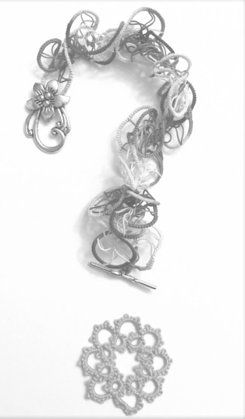
Choose Your Own Adventure Teacher: Natalie Rogers
Class Type: Project Level: All
Class Limit: 15

Do you find yourself overwhelmed by the last class on Saturday? Would you like a chance to practice the new skills you have learned without fear of messing up a pattern? Want to trigger your creativity? Come join me for a game of guided free-form tatting. Enjoy your own personal “chose your own tatting adventure.” Enter with thr ead in the color and size of your choosing and shuttles/needles at the ready. Accept m challenge and leave with a piece unique to you. I have challenges geared towards every tatting level from basic beginner to advanced. The rules are simple: 1) Have fun! 2) Pick a card, any card, and follow the directions. 3) Pick a new card and follow the directions. 4) Continue having fun! 5) Repeat #3 &4 until you have a design you are happy with or time has run out. 6) If inspiration strikes in the middle of a challenge, follow it and ignore all the rules (except 1, 4 & 7)! 7) Show off your work to the rest of the class.
Skills Required: Basic tatting skills.
Techniques Taught: Free form tatting.
Materials: For shuttle tatters – 2 shuttles, or shuttle and ball, wound in your choice of thread size and color. For needle tatters – tatting needle and thread in your choice of size and color, plus your basic tatting kit.
Kit: None

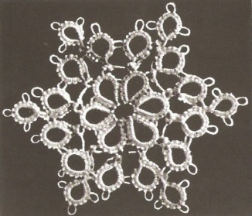
Weird Join / Interlocking Rings Teacher: Georgia Seitz
Class Type: Technique Level: Adv. Begin.
Class Limit: CLASS is FULL

Part 1. The motif is particularly interesting as a teaching pattern because of the join used to create the cloverleaf effect. It may be tatted with one shuttle, one needle, or one needle used as if it were a shuttle. The center may be tatted separately if a second color is desired. However, the motif may be tatted in one pass without cutting the thread with the use of a split ring to exit the center.
Part 2. Interlocking split rings tutorial. If you missed the split ring lanyard classes, here’s another chance to learn the technique.
Skills Required: Basic tatting skills: ring, chain, picot and join plus split ring.
Techniques Taught: Part 1 – joins, regular picot joins, joining the wrapped side of a split ring, shuttle lock join, alternate join which places a wrapped ds on a picot and a totally exotic join you may never want to use but which is found occasionally in vintage patterns. Part 2 – interlocking split rings.
Materials: Part 1 – 1 shuttle wound with 1 color of thread. Part 2 – 2 sets of 2 shuttles wound CTM, 2 colors of the same size thread.
Kit: None

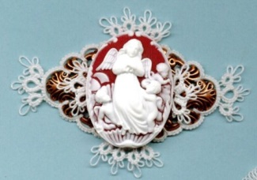
Cameo Pin Teacher: Lauren Snyder
Class Type: Project Level: Adv. Begin.
Class Limit: 15

You will have a choice of an orange or blue back cameo. Trim the metal filigree pin back as you see fit then mount the cameo and wear it home.
Skills Required: Basic tatting skills – ring, chain, picot, join.
Techniques Taught: Joining to a metal finding, using a picot gauge.
Materials: 1 or 2 shuttles wound with size 20 white thread, size 11, or smaller, crochet hook and your basic tatting kit.
Kit: Required, $2.00, includes 30x40 mm cameo, 35x60mm filigree pin back and plastic picot gauge. Extra kits may be available in the vending area.

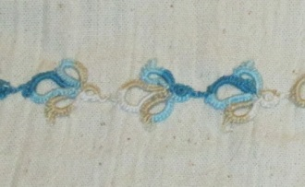
Flying Geese Edging Teacher: Karey Solomon
Class Type: Technique Level: Intermediate
Class Limit: 15

The tea towel edging is easy and fun to make, using picots and split rings to shape geese in flight, flying in a line or in formation. The pattern will teach several split ring skills – and most students will finish the project in class. We will also cover sewing an edging onto fabric so the design may retain its shape and go through the wash without harm for years to come.
Skills Required: Basic tatting skills – rings and chains
Techniques Taught: Split rings, ring on a split ring
Materials: 2 shuttles wound CTM with size 10 or 20 thread, plus your basic tatting kit.
Kit: Optional, $5.00 for cotton tea towel.

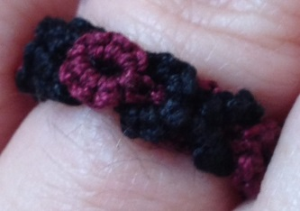
Hugs & Kisses Ring Teacher: Jessica Spaulding
Class Type: Technique Level: Intermediate
Class Limit: 15

In this class we will learn to weave one row of split rings into another row to create a dense and strong band. This technique has many uses. We will make a ring to practice, though students may also choose to start a bracelet.
Skills Required: Basics of split rings.
Techniques Taught: Weaving split rings
Materials: 2 shuttles wound CTM with 5 feet of size 10 or 20 thread on each shuttle. A second pair of shuttles wound in the same way with thread of the same size and a contrasting color, or bring the thread to wind on the first pair of shuttles. Basic tatting kit.
Kit: None

